**THARAKA** **COLLEGE**

**UNIVERSITY**

**SOFTWARE SYSTEM PROJECT**

**FALCULTY OF PHYSICAL SCIENCE AND TECHNOLOGY**

**DEPARTMENT OF COMPUTER SCIENCE**

**NAME: JOSHUA ANGAYA**

**REG: EDST1/05077/21**

**DESIGN ONLINE EXAMINATION MANAGEMENT SYSTEM**

**APPROVAL**

This Project Report was submitted to the College of Applied Science and Technology

To the lecture

Sign…………… Date………........

Department of Computer science

University applied Sciences and Technology for computer science

**DECLARATION**

I declare that this research report is original and has not been published or presented by other students.

JOSHUA ANGAYA Signature …………………… Date ……………………..

Department of computer science

Tharaka University College

**DEDICATION**

I dedicate it is for my passion to implement this project to the school with great fortune in my education and opportunity to do this research project work.

**ACKNOWLEDGEMENT**

I have taken effort in this project however it would have not been possible without the kind of support for the university and individual. I would like to express my gratitude towards the university and all my respected lecturers in the university who have given me great chance to undergo this project.

TABLE

APPROVAL………………………………………………………………………i

DECLARATION…………………………………………………………………..ii

DEDICATION ………............................................................ .............................. iii

ACKNOWLEDGEMENT ..................................................................................... .iv

TABLE OF CONTENTS.......................................................................................... v

ABSTRACT ............................................................................................................vii

CHAPTER 1: INTRODUCTION…………………………………………………..1

1.1. Background of Study….. ………………………………………………………2

1.2. Problem Statement…...........................................................................................3

1.3. objective and scope of study…………………………………………….……..4

1.4. project relevance and feasibility…………………………………………….….5

Technical feasibility………………………………………………………………..(i)

Economical feasibility…………………………………………………………….(ii)

CHAPTER 2: LITERATURE REVIEW…………………..……………….……...2

* 1. INTRODUCTION……………………………………………………………....1

**CHAPTER 3: METHODOLOGY …………………………………………11**

* 1. 3.1. Research Methodology……………………………………………11
  2. 3.2. Project Activities………………………………………………….11
  3. 3.3. Tools………………………………………………………….….14
  4. 3.4. Software Requirement Specification ……………………….…..17

**LIST OF FIGURES**

Figure 1: Waterfall Mode l……………………………………………1

Figure 2: Login ………………………………………………………2

Figure 3: registration …………………………………………………3

Figure 4: lectures page ……………………………………………….4

Figure 5: student report page ……………………………………..….5

Figure 6: adding question ………………………………………..…..6

Figure 7: mail sender …………………………………………..……7

Figure 8: about the system version ………………………………….8

Figure 9: student page ……………………………………………….9

Figure 10: selection of exam ………………………………………10

Figure 11: start exam ………………………………………………11

Figure 12: exam question ………………………………………….12

Figure 13: end of exam page …………………………….………..13

**LIST OF TABLES**

Table 1: survey………………………………………………………1

Table 2: user…………………………………………………………2

Table 3: Question and answer……………………………………….3

Table 4: result…………………………………………………….…4

**ABSTRACT**

Online examination management system is a software solution which allows institutes to arrange conduct and manage examination via online. This can be done through internet or intranet or local area network.

Some of the problem faced by manual examination system is delaying results, processing, filtering, filling poses a problem. Filtering of record searching is difficult. Maintain ace of system is also very difficult and takes a lot of time and effort.

To the system development lifecycle which is a conceptual model in using project management that describe the stages involved in the information system development project.

Online examination system is a software application which allows particular institutes to arrange, conduct, and manage examination via online. In this module candidates can be given exam online.

**CHAPTER 1: INTRODUCTION**

**1.1. Background of study**

Computerized and online systems have been increasing in every aspect of education.

Information Technology plays a very important role in nowadays education. Computers

and internet have made dramatic changes in the education system. Information

technology enables institution of high learning to save time and money, and allow the

delivery of education with easiness, anywhere, and anytime. Paper based books are

replaced by online and off-line applications. With computer software, we can be able to

have access to huge databases of information. This gives fundamental change to the

education. Information technology makes the exchanges of information fast and easily

**2.2 PROBLEM STATEMENT**

Irrigation may be the single most strategically important

intentional environmental modification humans have

learned to perform. While irrigation's impact has not

always been as critical to the global agricultural economy

and food supply as it today s. More time being used for lecturers to bring

the questions papers and answer sheets and also more time is needed for students in

order to write their exam, student are not satisfy with the current system of taking the

multiple choice examination. The no accuracy with current system when student did not

use a 2b pencil student are losing they are mark. Using the manual procedure of

conducting examination we not saving the environment by using more paper, we are in

the world where really need to take care of the

**Objectives and scope of study**

This project is aimed at developing an online examination system for introduction to

management for students and lecturers. The purpose of the system is to completely

automate the old manual procedure of conducting exam to a computerized System. I will

provide a more efficient examination system.

The system will allow students to register and take the exam. It enables also lecturers to

perform many tasks. The system has several functions. The users will do the registration

before using the system. The lecturers can upload questions and answers; he can view

the list of all students who take the exam. He can view the list of students who have

grade A, grade B, grade C, grade D and those who fail the exam. The lecturers can send

emails. Once logging, the students can choose the subject and take the exam. After

finishing using the software the users have a logout function that allows them to sign

out. This is because the system wants to ensure no external users can exploit the system.

**Project relevancy, feasibility**

**Technical Feasibility**

Building this system is technically feasible. The hardware and software needed are all

available, it not difficult to get them. Brief I can say the necessary resources needed for

the development and maintenance of the system are available. I am going to use java

programming languages and database.

1.4.2. Operationally Feasibility

The project I am developing is operationally feasible as there is no need for users to

have good knowledge in computer before using it. The user can learn and use the system

with easiness; he just needs to read the manual or tutorial from the developers.

**Economic Feasibility**

Besides being technically feasible, developing this system is economically feasible as

well. The development of the system does not require the developers to spend a lot of

money. The tools I will be using to develop the system are not expensive and the

software’s are open source. All I need is time. Even the maintenance of the system will

not be expensive. The system is indeed economically

**CHAPTER 2: LITERATURE REVIEW**

**2. Introduction**

Computerized systems have been increasing in education nowadays. Information

Technology plays a very important role in education. Computers have made dramatic

changes in the learning system. Information technology enables education institutions to

save space and time, and allow the delivery of education services with easiness,

anywhere, and anytime. For instance physical libraries are replaced by online libraries

available to anyone; anywhere in the world students can interact with lecturers online

whether live or via video. With computer software, we can be able to have access to

huge databases of information. This gives fundamental change to the education system.

Information technology makes the exchanges of information fast and easily.

With the growth of IT a lot of data can be found in online library. We don t need to have

a physical library in order to read books. Computers are a powerful tool used in all

aspects of our studies. We use multimedia technologies to convey ideas, build projects.

Information technology enables students to do distance learning, method of learning at a

distance instead of learning in a classroom. Communications technologies create

possibilities, both individual and institutional, for an unprecedented expansion of homebased learning, much of it part-time.

Information technology provides systems that allow students to perform many tasks in

an automatic way and not manually. Students can take exam using computerized

system; they don’t need paper-based exam. They save time and money when using

computer system in their studies.

**CHAPTER 3: METHODOLOGY**

**3.1 Research Methodology**

Main methodology activities held during the research is acquiring information and

knowledge about online examination system through reading books, and researches that

were previously done in related area. All the research materials were obtained over the

internet, Wikipedia and other websites.

Next step taken is reading, comprehending and analyzing literature review and matching

information obtained. This research emphasize online examination system, which

include usability, user-friendly interface, reliability, costing and meeting needs of target

users

**3.2 Project Activities**

In order to give solution to problems in an industry, software developer or a team of

developers must incorporate a development strategy that encompasses the process,

methods and tools layers and generic phases. This strategy is often referred to as process

model or a software developing paradigm. A process model for software developing is

chosen based on the nature of project and application, the methods and tools to be used,

and the controls and deliverables that are required. All software development can be

characterized as a problem solving loop in which distinct stages are encountered.

Regardless of the process model that is chosen for a software project, all of the stages

coexist simultaneously at some level of detail.

The methodology chosen to develop this system is waterfall model approach. I opted for

this method because I found that it is the best for my project where the stages involved

can assist my level of progress. Many developers prefer waterfall model and widely use

it as a development strategy.

Waterfall model approach is chosen because the approach allows the development of the

system to be revised after the stages is finished. Once the stages are not satisfied, then

going back to the previous stages can be considered necessary to add or modify any

features. The different stages for this model:

➢ Project Planning

➢ Requirements Design

➢ Design

➢ Development

➢ Integration and Testing

➢ Installation and Acceptance

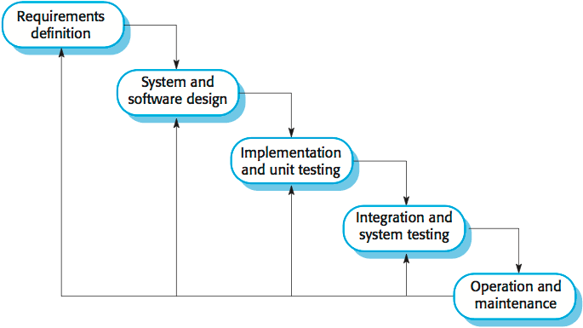

2.**1Planning**

The purpose of this phase is to determine the best solution and steps taken to develop the

system. Planning involves the details planning for the timing of the working progress

and types of technique will be taken next. Planning also involves that the methodology

that will going to use for this project.

3.2.2 Requirement Analysis

The purpose of this phase is to build logical model of this system. In addition, this phase

also needed to understand the applications, fact finding technique like document

reviews, surveys, observations, and sampling must be made to identify application

requirement, software requirement and hardware requirement. In this phase, what kind

of data requirement and the functional requirement will been decide.

**Design**

This phase will produce draft of the system architecture and the prototype of the

application that will satisfy all requirement analysis. At this phase the user interface and

all necessary input and process will be identify. This phase also determine the

application architecture, which is going to shows how to transform the logical design

into basic system coding to generate the first prototype of the system. The result for this

phase application interface and system design specification. For this project, the design

will be created using the Java Net beans.

**Implementation**

During this implementation phase, the system will be constructed. All codes are

generated inside this phase. At the end of this phase, system should running and most of

the function for the system should be able to use. Based from the previous phase, from

the prototype, the system will become the first version inside this phase

**Testing**

This phase will evaluate or verify the system that was developed. This phase will have a

simulation data which will simulate the true database for the system. This is to test the

functionality of the system in comparing a capture data with a database. Beside, all the

functionality that may cause errors or problems to the system must be specified inside

this phase because, the final result of the system is a very high priority and important.

However, the testing phase will only cover to overcome the problem statement and the

system objectives.

**Tools**

The tools required to develop the system are: Net Beans IDE 67.2, Microsoft Access

2007, MySQL in XAMPP, Microsoft Words 2007 and Gantt chart software.

3.3.1 NetBeans IDE 7.2

The NetBeans IDE is a free and open source software development tool that allow

developers to create enterprise, web, desktop, and mobile applications. The NetBeans

IDE 7.2 is an Integrated Development Environment available for Windows, Mac, Linux,

and Solaris. The NetBeans project consists of an open-source IDE and an application

platform which enable me to rapidly create the software using Java programming

language.

**Microsoft Project**

Microsoft Project is a project management software program, developed by Microsoft,

which is designed to assist a project manager in developing a plan, assigning resources

to tasks, tracking progress, managing the budget and analyzing workload

The application creates critical path schedules, and critical chain and event chain

methodology third-party add-ons also are available. Schedules can be resource leveled,

and chains are visualized in a Gantt chart. Additionally, MS Project can recognize

different classes of users. These different classes of users can have differing access

levels to projects, views, and other data. Custom objects such as calendars, views, tables,

filters, and fields are stored in an enterprise global which is shared by all users.

I use it to plan and manage the time more efficiently

**Microsoft PowerPoint**

This application is used for the documentation and presentation of the project. Microsoft

PowerPoint, usually just called PowerPoint, is a commercial presentation program

developed by Microsoft. It is part of the Microsoft Office suite, and runs on Microsoft

Windows and Apple's Mac OS X operating system.

**Operating System**

For the project I use Windows 7 64-bits which is the latest release of Microsoft

Windows, a series of operating systems produced by Microsoft for use on personal

computers, including home and business desktops, laptops; notebooks, tablet PCs, and

media center PCs.

**Hardware**

The hardware that I have used to develop the system is a laptop Asus vivo book with

Intel core i3 quad-core processor. The RAM is 4GB.

**Software Requirement Specification**

**. Functional requirement**

**Software product features**

**Login/Logout**

To assure the security of the system, the user should sign before starting using the

system and sign out after he finishes.

**Register**

Users should create an account and their data are registered in the database.

**Send Email**

Lecturers can send email to students to give some announcements regarding the exam

**Upload**

Lecturers can add questions and answers to the system

**View/ Student Report**

This allows lecturers to view the students who fail or pass the exam. They can view

according to grade A, B, C, D or F.

**Help**

This enables users to see the information about the system and also the user manual.

**Select**

This feature helps students to choose the subject and then proceed to answer the

questions**.**

**Non-functional requirement**

**Reliability**

The system can update its content in real time. Therefore, changes such as addition,

deletion or modification can be done immediately. This ensures that the content of the

system is up-to-date, reliable and can be trusted. The system will also be able to produce

all related output to queries.

**Availability**

The system can operate 24 hours per week and 365 days a year. As long as the user not

shut down the desktop. All the information will be keep in the database. Even though,

the desktop is shut off information still exist in the database.

**Security and Safety**

In order to avoid security and safety breach occur users need to login with username and

password before they access the system. In database there have record the username and

password. Only registered users can access the system and use it

**Maintainability**

The software is being developed by the Java NetBeans IDE 6.8. Thus the system can be

update in the coding part to maintain the system.

**Portability**

The system is being developed using Java programming language and MySQL. Before

the system release to system needs to compile without any error before the system run.

Therefore, the software will be able to run on any computer with NetBeans IDE 6.8 and

MySQL.

**Performance**

The system performance is very fast. The processed transactions and event response

time is quick. So user can do the transaction any event without feel stress on waiting.

**Flexibility**

System is working easily on the Intranet with the username and password of the user.

The system has given the rights to the lecturers and the students to use the system with

their username. The system can also work on other kind of technology with the little

modification. System should be quite flexible to install and maintain.

**Efficiency**

System should be efficient enough to meet all kinds of requirements as required by the

lecturers and students. The system should not hang or lose its efficiency in any kind of

worse conditions. It should provide the correct output in all manners.

**User Friendliness**

System should be user friendly, so that any user can use and access the system with

easiness.

**Use case diagram**

The unified modeling language used is use case diagram. A use case is a set of scenarios

that describes an interaction between a user and a system. A use case diagram displays

the relationship among actors and use cases. The two main components of a use case

diagram are use cases and actors. The actors in our system are students and lecturers.

The use case diagram is designed in the following fjigure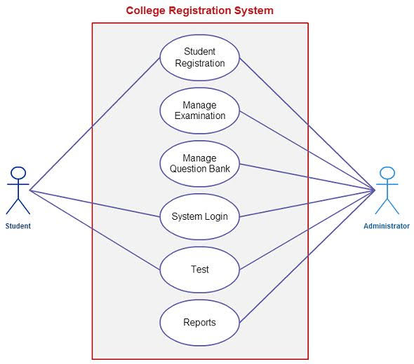

**System flowchart**

A system flowchart is a valuable presentation aid because it shows how my system

major components fit together and interact. In effect, it serves as a system roadmap

. 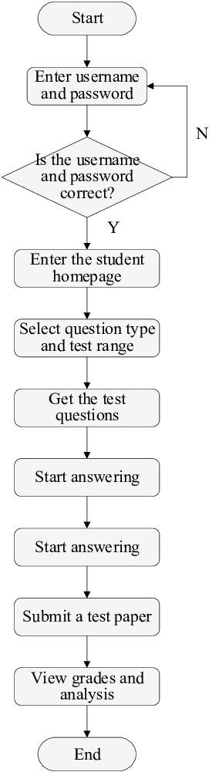

**Entity relationship diagram**

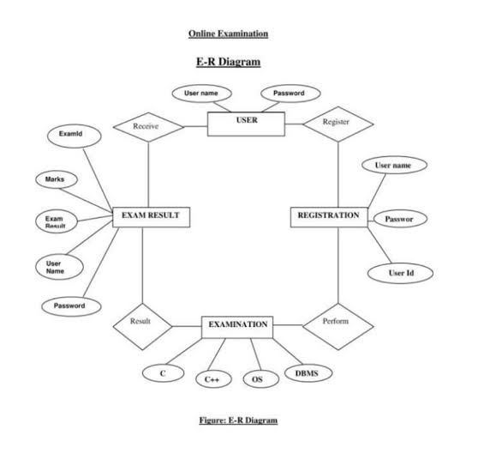

**Context Diagram**

The Context Diagram shows the system under consideration as a single high-level

process and then shows the relationship that the system has with other external entities.

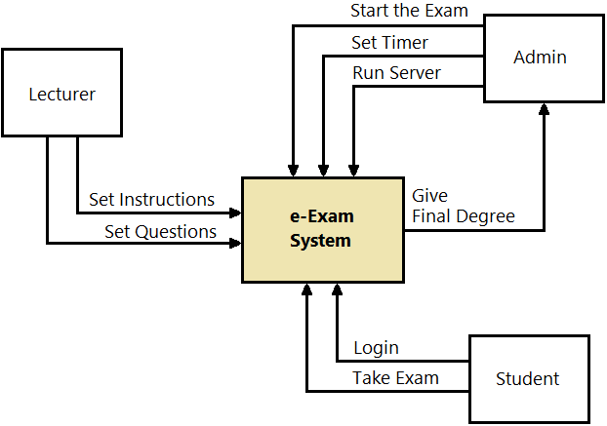

**Database design**

The database is used for the purpose of handling information as an integrated whole.

It is defined as a collection of interrelated data stored with less or no redundancy to

serve many users quickly and effectively. We should design a database to see how

data should be organized around user requirements. The objective of the database is

to make information access, easy quick, inexpensive and flexible for other users.

During database design the following objectives are concerned:

➢ Controlled Redundancy

➢ Data independence

➢ Accurate and integrating

➢ More information at low cost

➢ Recovery from failure

➢ Privacy and security

➢ Performance

**INTERFACE REQUIREMENTS**

The user interface should be designed to make the user’s work easier and more

effective and the principles for good interface design include concern for content and

context for navigation through activities, aesthetic consideration, assistance for

novices and experts, consistency, and minimizing user effort.

4.7.1 **Principles for User Interface Design**

The graphical user interface (GUI) is the most common type of interfaces most

students are likely to use personally and for developing systems. The principles of

interface are shown as follow:

Layout – The interface should be a series of areas on the screen that are used

consistently for different purposes

Content awareness – Users should always aware where they are in the system and

what information is being displayed

Aesthetics – make interface look pleasing

User experience – Ease of use and ease of learning based on users’ level of

experiences

Consistency – enables users to predict what will happen before they perform the

function.

**Minimal user effort:**

➢ The interface should be simple to use.

➢ The screen: Information can be presented in multiple areas

➢ Like areas should be grouped together.

➢ Areas and information should minimize user movement from one to

another.

➢ Ideally, areas will remain consistent in Size, Shape, and Placement for

entering data, and Reports presenting retrieved

**Consistency**

➢ Most important factor - enables users to predict what will happen.

➢ When interfaces are consistent, users can interact with one part of the

system, and then know how to interact with the rest.

➢ Reduces learning curve.

**Content Awareness**

➢ All interfaces should have titles.

➢ Menus should show: where you are and where you came from to get

there.

➢ It should be clear what information is within each area.

➢ Fields and field labels should be selected carefully.

➢ Use dates and version numbers to aid system users.

**Aesthetics**

➢ Interfaces need to be functional and inviting to use.

➢ Avoid squeezing in too much, particularly for novice users.

➢ Design text carefully.

➢ Be aware of font and size.

➢ Avoid using all capital letters.

➢ Colors and patterns should be used carefully

➢ Test quality of colors by trying the interface on a black/white

monitor.

➢ Use colors to separate or categorize items e.g. showing difference

between headings and regular text.

➢ The goal is pleasant readability, not art; color and patterns should

be used to strengthen the message.

➢ Colors with high contrast should be used (e.g. Black & white).

**TEST PLAN**

4.8.1 Features to be tested

**Interface**

We test how the system interacts with the environment and users. The system

needs to be friendly user interface, such as beautiful, colourful, attractiveness.

The interface will make the users to be easy to understand and perform our

functions. It will minimize users less effort.

**User registration**

From testing part, this features need to be tested whether user registration

feature meet some requirements especially security requirements. Firstly, in

order for users to use the system, they need to be registered. We provide

features for member registration. This feature must have the capability to

provide a form in order to get the details about the user’s information like

user’s name, username, password and category. Besides, those users who did

not complete filling the registration form should not be allowed get access to

the other section of the system.

**Send mail**

This feature allows lecturers to send mail to students.

**Add questions**

Enable lectures to add questions and answers into the system

work properly. Integration tests will focus the flow of control among the classes and

on the data exchanged among them.

. **User Interface Testing**

The testing is done for normal integration testing, done by moving through each and

every menu item in the interface either in a top – down or bottom – up manner. The

testers will test each interface function, based on the interface design sources.

**Use – Case Testing**

The tester tests each use case, with the test plan source is use case diagram, when the

user interface is important. Testing is done by moving through each use case to

ensure they work correctly.

**Interaction Testing**

When the system performs data processing, the tester will use interaction testing.

This testing will be performed base on some diagrams, such as class diagrams,

sequence diagrams as well as communication diagrams. Interaction testing tests each

process in a step – by – step fashion. Each class is added in turn and results of the

class compared to the correct result from the test data. When a class passes, the next

class is added and the test rerun. This is done for each package. Once each package

has passed all tests, and then the process repeats integrating the packages.

. **System Interface Testing:**

Because of data will be transferred between systems are often automated and not

monitored directly by the users. So, it is critical to design tests to ensure they are

being done correctly. The system interface testing will be used when the system

exchange data with other systems, based on the use case diagram.

**System Testing**

System testing is similar to integration testing but is much broader in scope. It

includes some kinds of testing.

. **Requirements Testing**

Requirements testing will answer the question for normal system testing: How well

the system meets business requirements? This testing will use system design, unit

tests and integration tests to answer, and ensure that changes made as a result of it

did not create new errors. And besides, the testers often pretend to be uniformed

users and perform improper actions to ensure the system is immune/avoid to invalid

actions.

**Usability Testing**

The testers will use usability testing when user interface is important. It is based on

the interface design and use case diagram to answer the question: How convenient

the system is to use? It is done by the analyst with experience in how users think and

in good interface design.

**Security Testing**

When the system is important, the testers will based on the infrastructure design to

test the disaster recovery and unauthorized access. The security testing is quite

complex, usually be done by an infrastructure analyst assigned to the project, or can

hire professional firm, to answer the question: How secure the system is?

.**performance testing**

The performance testing will answer the question: How well the system performs

under a heavy load? This testing will used base on the system proposal and

infrastructure. The testers will perform this testing by high volumes of transactions

are generated and given to the system.

**Documentation Testing:**

And the last one in system testing is documentation testing. The test plan source of it

will be help system, procedures as well as tutorial to test the accuracy of the

documentation. The testers will check every item on every page in all documentation

to ensure that the documentation items and examples work properly.

TEST CASES

Test Case ID: 1

Function to be tested: Register

Test Description: To register a user

**Test Objective: To ensure new user can register as member**

Test Execution:

1. Launch the application

2. Enter ID

3. Enter Password

4. Mobile Number

5. Category

6. Click Save button

Expected Result: User will be successfully registered

Actual Result: Pass

Test Case ID: 2

Function to be tested: Login

Test Description: Enable registered users to log in to the

Test Objective: To ensure registered users enter valid username and password while

logging in.

Test Execution:

1. Enter ID

2. Enter password

3. Click Login button

Test Data :

1. ID – 12272

2. Password – 1234

Expected Result: User will be successfully log in

Actual Result: Pass

Function to be tested: send email

Test Description: To send an email

**Test Objective: To ensure an email can be sent**

Test Execution:

1. Enter recipient address

2. Enter Subject

3. Browse file if there is

4. Write message

5. Click Send button

Expected Result: The message will be successfully sent

Actual Result:

Function to be tested: Add questions

Test Description: To add questions and answers into the system

Test Objective: To ensure questions and answers can be added

Test Execution:

1. Enter subject code

2. Question number

3. question

4. choice1

5. choice2

6. choice3

7. choice 4

8. correct answer

9. Click Save button

Expected Result: The above will be successfully saved

Actual Result: Pass

Test tools needed.

For this system, there is no special test tool. It is because the system desktop

application and we are testing it by using the scenario-based cases using personal

computers such as laptop or desktop. For example, the tester of this system will put

particular data into that system and see whether the expected output will come out or

not.

**CONCLUSION & RECOMMANDATION**

**CONCLUSION**

With the completion of this project I conclude that it has achieved its purpose. The

whole project provides a base for students to take their exam using software and

allow lecturers to add questions and answers into the system. The system is

developed using Java programming language and data are saved in the database.

Online examination system for introduction to management course is the best

compared to paper-based exam. The automated system helps students and lecturers

to save time and makes the process faster. It saves space since answers papers will

not be used. With a user friendly system that has security, integrity and the database

is neither inconsistent nor redundant.

**Recommendations**:

The project has been accomplished and an application was developed to solve the

aforementioned problems. For further development, there are some recommendations

on this project:

The application should support an automated time setting to let the student know

how many hours and minutes are left for them to complete the examination.

**REFERENCES**

[1] Nijaz.(2000). Dynamic Web-based Application Development. New

York:Prentice Hall

[2] Enright, A.G., and Libert, T., "The Web: It's not just for E-mail Anymore",

American Society for Engineering Education (ASEE) Annual Conference

Proceedings, Charlotte, North Carolina, 1999.

[3] Newton, Harry, "Newton’s Telecom Dictionary", 14th Edition, 1998

[4] Ritchey, Tim, and Shobe, Matt, "JavaScript For Macintosh", 1996

[5] Harold, Elliotte Rusty, "Java Network Programming", 1997

[6] Biedny, David, and Monroy, Bert, "Adobe Photoshop Handbook", 2.5 Edition,

1993

[7] Alba, J.W. and Barton Weitz, J.L. (1997), “Interactive home shopping:

consumer, retailer, andmanufacturer incentives